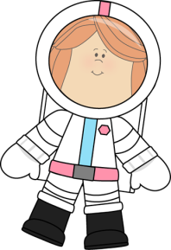
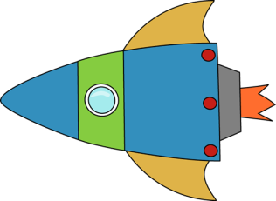
Second Grade News!
September 19-23, 2016
Reading and Spelling Tests: September 23
Announcements:
9/27-Picture Day
9/30-Rosh Chodesh Assembly

Reading Story and Skills:  Story: Exploring Space with an Astronaut, by Patricia J. Murphy  Phonics/Fluency:  Long vowels VCe  Text Based Comprehension:  Main Idea and Details, Text Structure  Language – Sentences, Subjects  Writing: Expository Nonfiction | Selection Vocabulary Words:  - astronaut – a person who goes into space  - gravity – the natural force that makes everything on Earth move toward it  - telescope – an instrument that makes things that are far away appear to be close  - experiment – a careful test or trial to find out about something  - shuttle – a vehicle that carries astronauts into space  Amazing Words:  - ascend – to go up  - descend – to go down  - orbit – a path one thing makes around another thing in space  - universe – made up of Earth, the sun, the moon, and all of the other planets and stars in space  - enormous – very, very large  - journey – a long trip  - launch – to get something started or set it going  - meteorite – a piece of stone or metal that hits something in space  High Frequency Words:  everywhere, move, world, live, woman, machines, work
Reading/Math/Spelling  Reading Math  Monday ½ page 1 ½ page 1  Tuesday ½ page 2 ½ page 2  Wednesday ½ page 3 ½ page 3  Thursday ½ page 4 ½ page 4  Spelling: OPTIONAL enrichment activities are attached (Tic-Tac-Toe activities). Use as review/practice for the test on Friday! |  |  | Fluency/ Reading Log  Fluency: Read the passage nightly. Answer one question each night. Track the total words read per minute on the sheet.  Reading Log: Read 15 minutes per night. Log it on your reading log and turn it in at the end of September.
Spelling Words:
- page  - nose  - space  - size  - fine |  | - mice  - late  - huge  - blaze  - race | - rice  - vote  - move  - live

