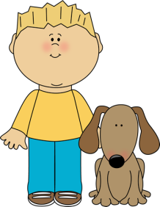
Second Grade News!
September 26-30
Reading and Spelling Tests: Friday, September 30
Announcements:
September 27: Picture Day
September 30th: Rosh Chodesh Assembly, 8:30AM

Reading Story and Skills:  Story: Henry and Mudge and the Starry Night, by Cynthia Rylant  Phonics/Fluency:  consonant blends  Text Based Comprehension:  Character and Setting, Story Structure  Language – Predicates  Writing: realistic fiction, organization | Selection Vocabulary:  - shivered – shook with fear  - snuggled – cuddled together  - drooled – let saliva run from the mouth  - lanterns – lights inside containers that can be carried  Amazing Words:  - galaxy – a very large group of stars  - tranquil – very calm and peaceful,  - wildlife- animals and plants that live outdoors  - fledglings- young birds that have just grown feathers to fly  - secure- firmly fastened  - detective- a person who tries to solve a mystery  - fascinating- very interesting  - slimy- slippery and sticky  High Frequency Words:  bear, father, straight, build, love, couldn’t, mother
Language Arts/Math  Reading Math  Monday ½ page 5 ½ page 5  Tuesday ½ page 6 ½ page 6  Wednesday ½ page 7 ½ page 7  Thursday ½ page 8 ½ page 8  Spelling: OPTIONAL enrichment activities are attached (Tic-Tac-Toe activities). Use as review/practice for the test on Friday! |  |  | Reading/Fluency  Fluency: Read the passage nightly. Answer one question each night. Track the total words read per minute on the sheet.  OPTIONAL Reading Log: Read 10 minutes per night. Log it on your reading log and turn it in at the end of September.
Spelling Words:
- stop  - strap  - nest  - hand  - brave |  | - ask  - clip  - stream  - mask  - twin | - breeze  - state  - couldn’t  - build

