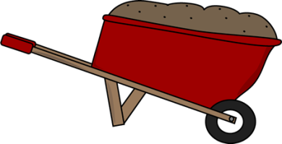
Second Grade News!
February 6-10, 2017
Reading and Spelling Tests: Friday, Feb. 6th
Announcements
INTERGENERATIONAL DAY-February 9th (Grades K-8)

Reading Story and Skills:  Story: “Soil” by: Sally M. Walker  Phonics/Fluency:  diphthongs: ou, ow, oi, oy  Text Based Comprehension:  fact and opinion, questioning  Language – comparative and superlative adjectives  Writing: Biography reports | Selection Vocabulary Words:  - grains- tiny bits of sand, sugar, or salt  - seeps- flows very slowly through something  - materials-what things are made from or used for  - substances- materials that something is made of  - particles-very little pieces of something  - texture- the feel that things have because of the way they are made  Amazing Words:  - discovery – to see or learn about something for the first time  - underneath – below something  - fine – very tiny or small  - landscape – everything you can see when you look across an area of land, including hills, buildings, rivers and trees  - transform- to change
Mandatory Homework  Reading Math Fluency  Monday ½ page 53 ½ page 53 Read passage; answer 1 question  Tuesday ½ page 54 ½ page 54 Read passage; answer 1 question  Wednesday ½ page 55 ½ page 55 Read passage; answer 1 question  Thursday ½ page 56 ½ page 56 Read passage; answer 1 question |  |  | Bonus (non-mandatory) homework  Read 10 minutes per night aloud and log it on the monthly Reading Log for January  Spelling Tic-Tac-Toe Activities
Spelling Words:
- around  - out  - gown  - sound  - flower |  | - howl  - ground  - pound  - crown  - south | - mouse  - downtown  - world  - push
