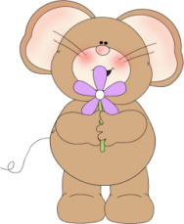
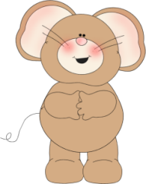
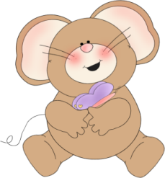
Second Grade News!
March 27-March 31, 2017
Reading and Spelling Tests: Friday, March 31
Announcements
March 28th: Rosh Chodesh Assembly 3PM
Reading Story and Skills:  Story: “Horace and Morris but mostly Dolores,” by: James Howe  Phonics/Fluency:  consonant patterns: ph, gh, ck, ng  Text Based Comprehension:  character and setting, story structure  Language – different kinds of pronouns  Writing: animal fantasy | Selection Vocabulary Words:  - adventure – an exciting experience  - climbed – went upward  - clubhouse – a house or structure where a group meets  - exploring – going someplace to discover what it is like  - greatest – the best or most wonderful  - truest – the most real or loyal  - wondered – wanted to know more  Amazing Words:  - appreciate – to feel thankful for something  - respect – to feel or show honor for someone or something  - firmly – to say something in a determined way that shows you won’t change your mind  - defiant – not obedient  - communicate – to give someone information in ways such as talking, writing, drawing, or using sign language
Mandatory Math/Reading/Fluency  Reading Math Fluency  Monday ½ page 81 ½ page 81 Read passage; answer 1 question  Tuesday ½ page 82 ½ page 82 Read passage; answer 1 question  Wednesday ½ page83 ½ page83 Read passage; answer 1 question  Thursday ½ page 84 ½ page 84 Read passage; answer 1 question |  |  | Optional “Bonus” Activities  - Read 10 minutes per night aloud and log it on the monthly Reading Log for March! Turn it in on FRIDAY!!  - Spelling Tic-Tac-Toe
Spelling Words:
- phone  - enough  - stuff  - laugh  - puff |  | - giraffe  - graph  - tough  - photo  - rough | - cough  - cliff  - half  - front

