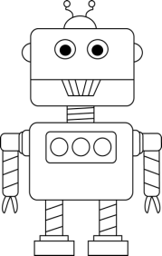
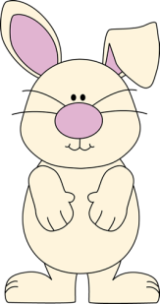
Second Grade News!
December 5th-9th
Reading and Spelling Tests: Friday, December 9th
Announcements
Dec 8th: End of Trimester 1
Dec 12th-22nd: Book Fair
Dec 15th: Parent Teacher Conferences (No School)

Reading Story and Skills:  Story: Pearl and Wagner by: Kate McMullan  Phonics/Fluency:  Vowel patterns e, ee, ea, y  Text Based Comprehension:  Author’s purpose, questioning  Language – voice, verbs  Writing: fantasy | Selection Vocabulary Words:  - robot – a machine with moving parts that is controlled by a computer  - wad – a round lump  - trash – something of little use, things to be thrown away  - electricity – energy that makes light, heat, motion, or force  Amazing Words:  - sidekick – a good friend or partner  - unique – the only one like it  - contraption – something put together in a strange way  - foolproof – so simple and safe that anybody can use it  - daydream – thinking of pleasant things while you are awake  - project – something you plan and then do  - scrap – a small piece left over from something  High Frequency Words:  guess, shoe, won, pretty, village, science, watch
Math/Reading  MANDATORY (Required):  Reading Math  Monday ½ page 21 ½ page 21  Tuesday ½ page 22 ½ page 22  Wednesday ½ page 23 ½ page 23  Thursday ½ page 24 ½ page 24  OPTIONAL:  Spelling: Enrichment activities (Tic-Tac-Toe). Use as review/practice for the test on Friday! |  |  | Reading/Fluency  MANDATORY (Required):  Fluency: Read the passage nightly for ONE MINUTE with a parent. Answer one question each night. Parents must track the total words read per minute on the sheet.  OPTIONAL:  Reading Log: Read 10 minutes per night. Log it on your reading log and turn it in at the end of December
Spelling Words:
- read  - deep  - wheel  - sleep  - feet |  | - seat  - leave  - teeth  - easy  - party | - windy  - team  BONUS WORDS  - guess  - shoe

