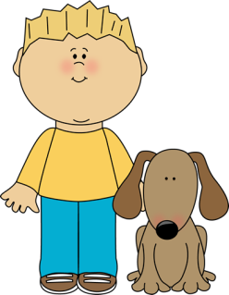
Second Grade News!
December 12-16th
Reading and Spelling Tests: Friday, December 16th
Announcements
Dec 8th: End of Trimester 1
Dec 12th-22nd: Book Fair
Dec 15th: Parent Teacher Conferences (No School)
Reading Story and Skills:  Story: Dear Juno by: Soyung Pak  Phonics/Fluency:  Vowel patterns o, oa, ow  Text Based Comprehension:  draw conclusions, visualize  Language – verbs with singular and plural nouns  Writing: friendly letter | Selection Vocabulary Words:  - persimmons – yellow- and orange- colored sweet fruits that are like plums  - photograph – a picture taken with a camera  - envelope – a paper sleeve that is used to hold a letter  - smudged – smeared or marked with dirty streaks  Amazing Words:  - correspond – to exchange letters with someone  - transport – to carry from one place to another  - footprint – a mark made by a foot  - imitate- to try to be like a person or thing  - postage – money paid to mail a letter or package  - cove – a small part of a sea or lake that is sheltered and nearly surrounded by land  - deaf – not to hear  - sign language – a way of talking by making signs with your hands  High Frequency Words:  answer, parents, wash, company, picture, faraway, school
Math/Reading  MANDATORY (Required):  Reading Math  Monday ½ page 25 ½ page 25  Tuesday ½ page 26 ½ page 26  Wednesday ½ page 27 ½ page 27  Thursday ½ page 28 ½ page 28  OPTIONAL:  Spelling: Enrichment activities (Tic-Tac-Toe). Use as review/practice for the test on Friday! |  |  | Reading/Fluency  MANDATORY (Required):  Fluency: Read the passage nightly for ONE MINUTE with a parent. Answer one question each night. Parents must track the total words read per minute on the sheet.  OPTIONAL:  Reading Log: Read 10 minutes per night. Log it on your reading log and turn it in at the end of December
Spelling Words:
- goat  - hold  - show  - most  - bowl |  | - float  - toast  - ago  - open  - told | - toad  - slow  BONUS WORDS  - answer  - school

