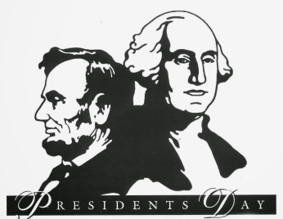Second Grade News!
February 20-24, 2017
Reading and Spelling Tests: Friday, February 24
Announcements
February 20: NO SCHOOL (President’s Day)
Reading Story and Skills:  Story: “Helen Keller and the Big Storm” by: Patricia Lakin  Phonics/Fluency:  Oo, ue, ew, ui  Text Based Comprehension:  Details and Facts/Ask Questions  Language – adverbs that tell how  Writing: Biography Project | Selection Vocabulary Words:  Angry, branches, clung, fingers, picnic, pressing, special  Amazing Words:  Weather Conditions: the atmospheric conditions that comprise the state of the atmosphere in terms of temperature and wind and clouds and precipitation.  Predict: say or estimate that (a specified thing) will happen in the future or will be a consequence of something.  Terrifying: cause to feel extreme fear.  Breeze: a gentle wind.  funnel : a tube or pipe that is wide at the top and narrow at the bottom, used for guiding liquid or powder into a small opening.  Swirl: move in a twisting or spiraling pattern.
Mandatory Homework  Reading Math Fluency  Monday *BONUS PAGE* (No School) ½ page 61 ½ page 61 Read passage; answer 1 question  Tuesday ½ page 62 ½ page 62 Read passage; answer 1 question  Wednesday ½ page 63 ½ page 63 Read passage; answer 1 question  Thursday ½ page 64 ½ page 64 Read passage; answer 1 question |  |  | Bonus (non-mandatory) homework  Read 10 minutes per night aloud and log it on the monthly Reading Log for January  Spelling Tic-Tac-Toe Activities
Spelling Words:
- too  - new  - fruit  - blue  - true |  | - cool  - suit  - spoon  - clue  - juice | - drew  - flew  BONUS WORDS  - know  - won’t

